Project Development Phase
Model Performance Test

Date | 23 june 2025
Team ID | LTVIP2025TMID21049
Project Name | Project-Flight finder-navigating your air travel options
Maximum Marks | 4

Model Performance Testing:
Project team shall fill the following information in model performance testing template.
S.No. | Parameter | Values | Screenshot
1. | Model Summary | - | 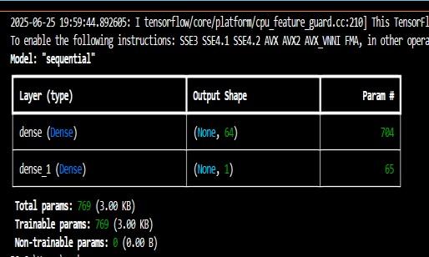
2. | Accuracy | Training  Accuracy –  0.71  Validation  Accuracy – 0.45 | 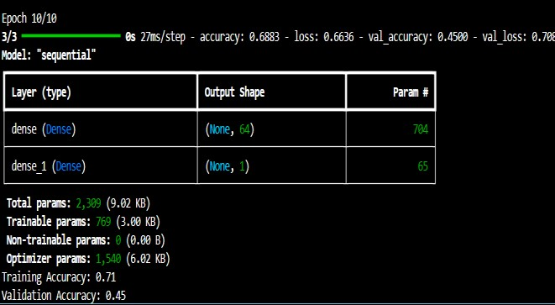
3. | Fine Tunning  Result( if  Done) | Validation  Accuracy 0.94

